**ASSIGNMENT-3**

**Name: Kishore R**

**Reg no: 715519106304**

**College Name: PSG Institute of Technology and Applied Research**

***PROGRAM FOR TRAFFIC LIGHT***

**Python Code:**

void setup() {

  // put your setup code here, to run once:

  Serial1.begin(9600);

  pinMode(21, OUTPUT);

  pinMode(20, OUTPUT);

  pinMode(19, OUTPUT);

}

void loop() {

  // put your main code here, to run repeatedly:

  digitalWrite(21, HIGH);

  delay(3000); // this speeds up the simulation

  digitalWrite(21, LOW);

  digitalWrite(20, HIGH);

  delay(3000);

  digitalWrite(20, LOW);

  digitalWrite(19, HIGH);

  delay(3000);

  digitalWrite(19, LOW);

}

**OUTPUT:**

**Traffic Lights For Raspberry Pi**

**Blinking Red Light:**

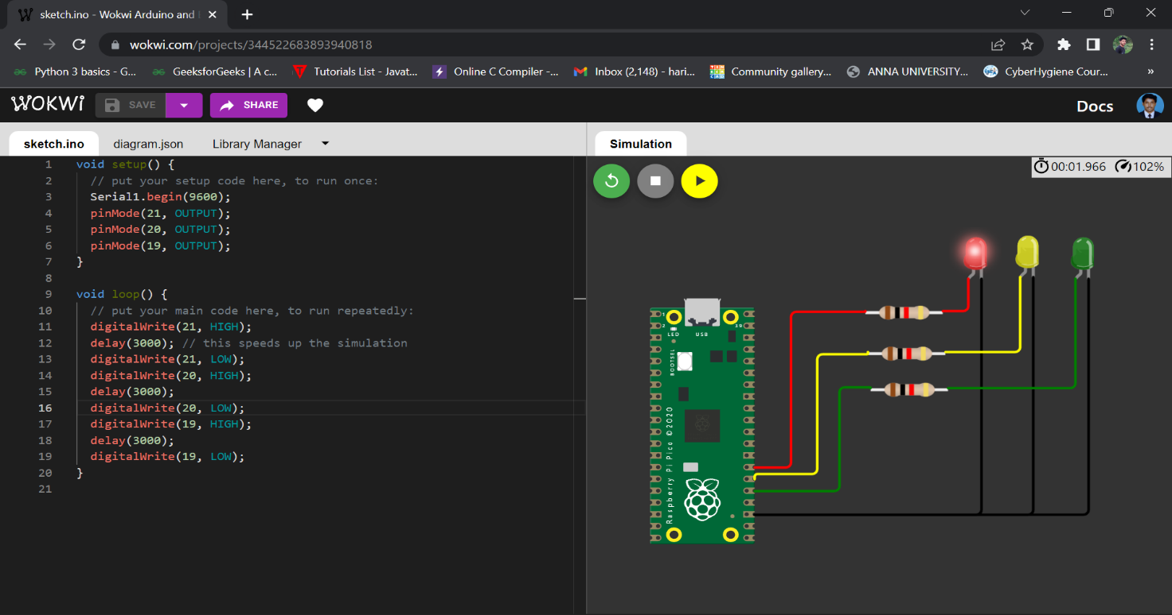

**Blinking Yellow Light:**

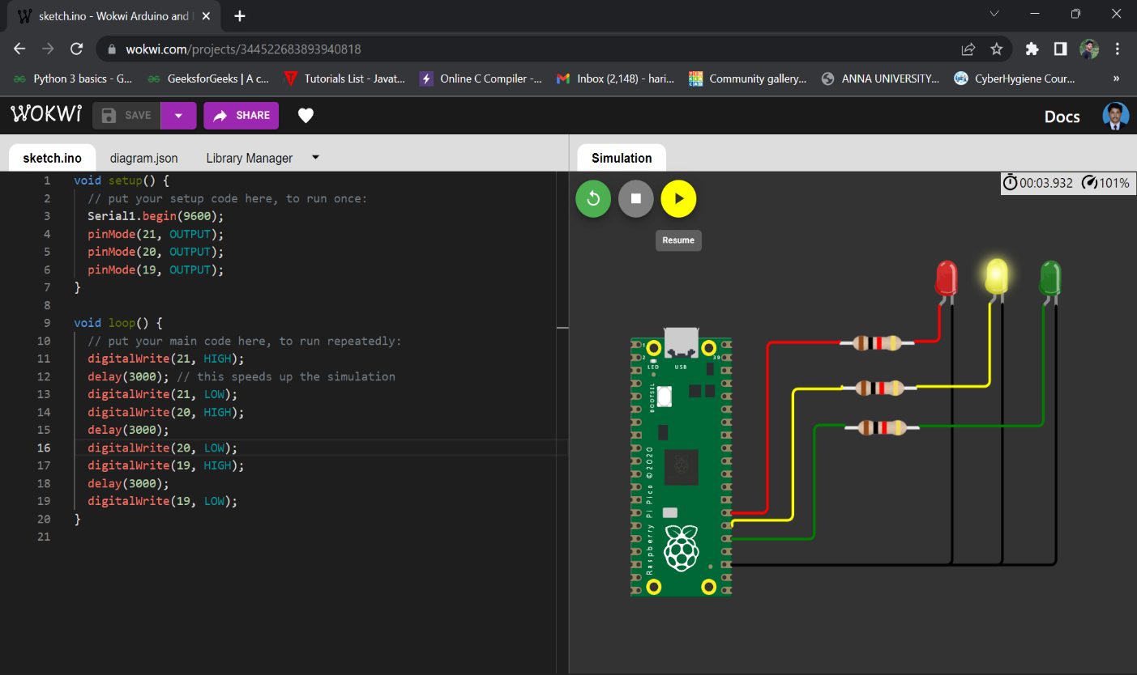

**Blinking Green Light:**

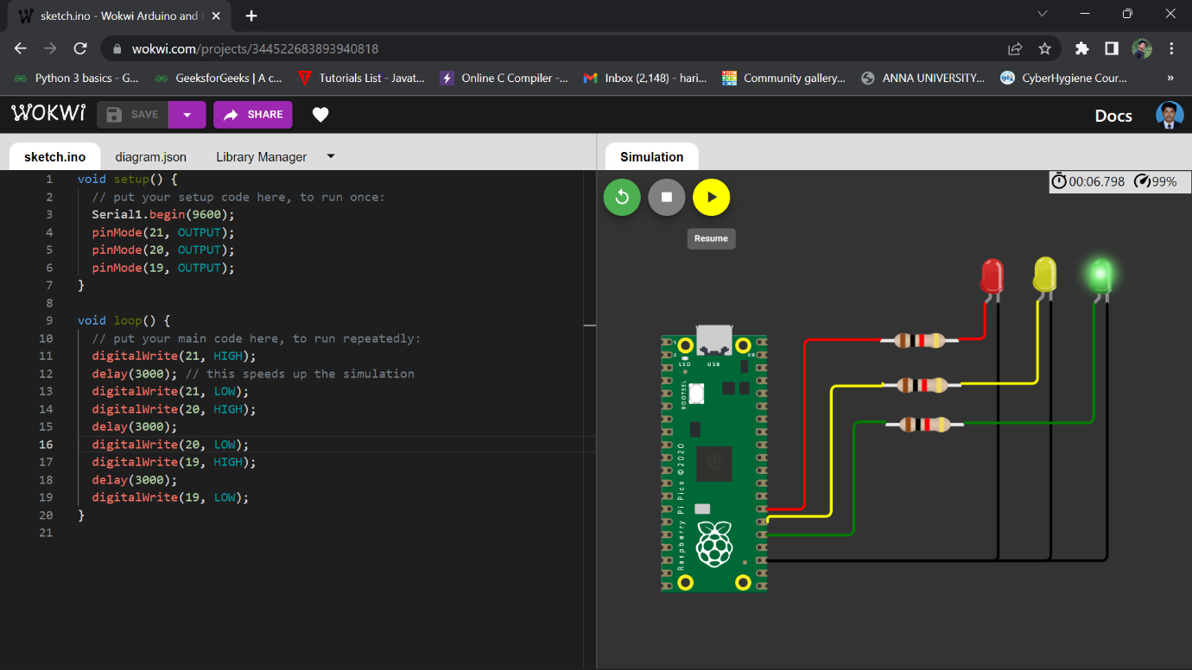

**BLINKING LED:**

**PROGRAM FOR BLINKING LED:**

**Python code:**

void setup() {

  // put your setup code here, to run once:

**Serial**.begin(9600);

  pinMode(22, OUTPUT);

}

void loop() {

  // put your main code here, to run repeatedly:

  digitalWrite(22, HIGH);

**Serial**.println("LED ON");

  delay(2000);

  digitalWrite(22, LOW);

**Serial**.println("LED OFF");

  delay(2000);

}

**Output:**

**Blinking LED For Raspberry pi:**

